**Vibration/Shock Sensor Module (SW420)**

Vibration sensor module alarm Motion sensor module vibration switch SW-420 module based on the vibration sensor SW-420 and Comparator LM393 to detect if there is any vibration that beyond the threshold. The threshold can adjust using an onboard potentiometer. When this no vibration, this module output logic LOW the signal indicates LED light, and vice versa.

**If the module does not vibrate, the vibration switch was closed on state, the output of low output, the green indicator light. The product vibrates, vibration switches momentary disconnect, the output is driven high, the green light does not shine.**

The output can be directly connected to the microcontroller, which to detect high and low level, so as to detect whether the environment exists vibration, play a role in the alarm.

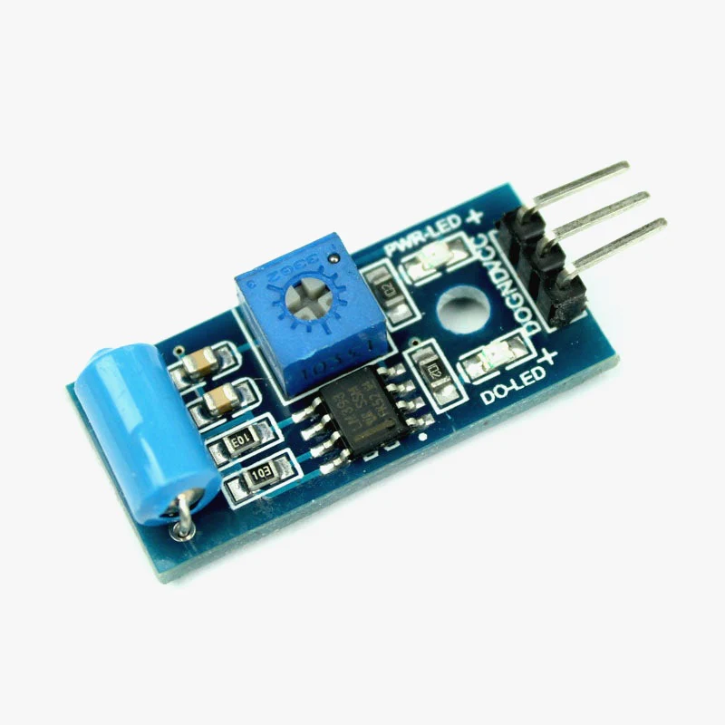

### **Technical SPECIFICATIONS:**

| **Specification** | **Value** |
| --- | --- |
| Sensor Type | Vibration Sensor |
| Sensing Method | Piezoelectric or Accelerometer |
| Sensitivity Range | Varies (e.g., mV/g or mV/m/s²) |
| Frequency Response | 1 Hz to X Hz |
| Output Type | Analog Voltage or Digital |
| Operating Voltage | 3.3V - 5V |
| Operating Temperature | -20°C to +70°C |

### **PRODUCT DESCRIPTION**

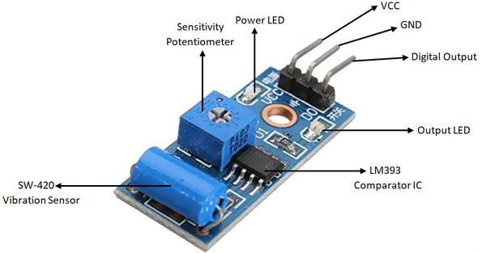

To connect it with Microcontrollers like [Arduino](https://quartzcomponents.com/search?type=product&q=Arduino)/ [Raspberry](https://quartzcomponents.com/products/raspberry-pi-3-model-b?_pos=3&_sid=45077a432&_ss=r) Pi/[NodeMcu](https://quartzcomponents.com/pages/search-results-page?q=node+mcu), [ESP8266](https://quartzcomponents.com/pages/search-results-page?q=esp8266+), [ESP32](https://quartzcomponents.com/pages/search-results-page?q=esp32+development), etc. just power the device using VCC and GND pins and connect the Digital Output to any Digital I/O pin of the Microcontroller you are using.

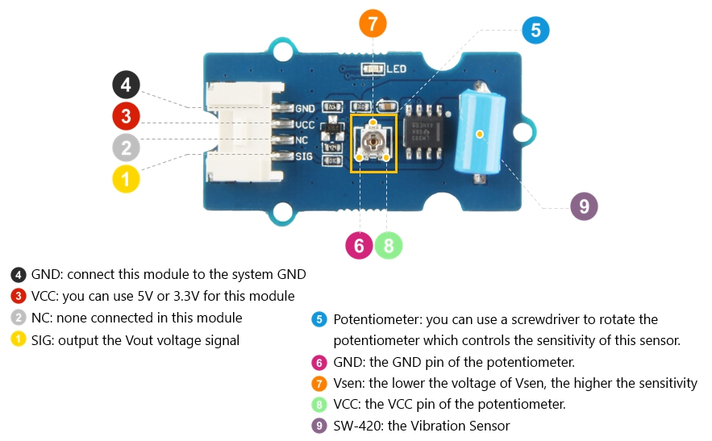

### **Detecting vibrations with SW-420**

The SW-420 vibration sensor module is able to sense vibration/impact at any level. It’s a pretty cheap sensor module that demands little external electronics to get to work. Since it provides a simple HIGH/LOW output (a positive pulse output upon vibration) it can be easily linked with some other electronics circuits. At the same time, you can define the trigger threshold using the onboard trimpot (the trimpot setting may or may not be essential for your intended application, though).

As stated before, if everything goes well, the output of the module is LOW when the module is stable. When a vibration or movement occurs, the module will briefly give a HIGH output. See another random oscillogram below.

**Circuit diagram:**

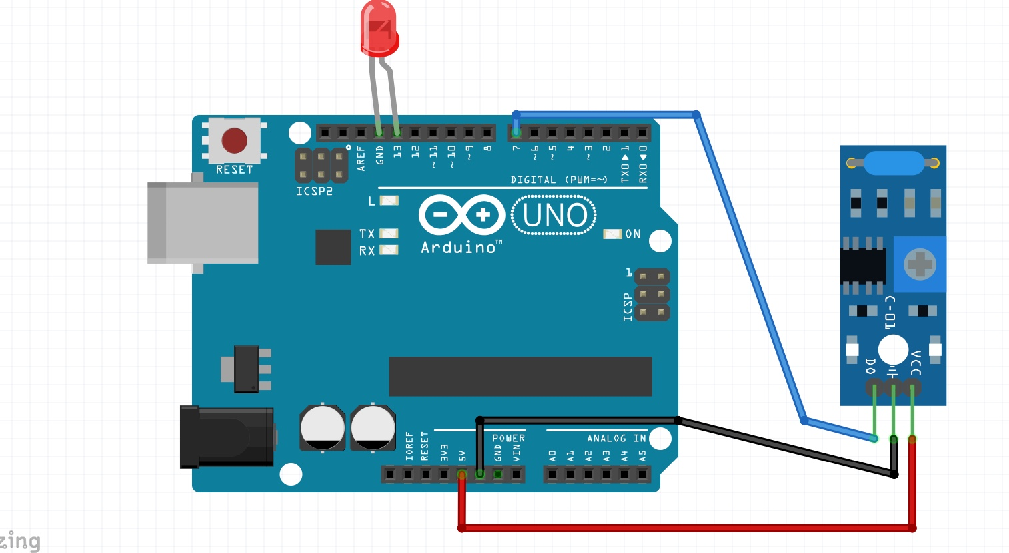

**Code:**

int vib_pin=7;

int led_pin=13;

void setup() {

pinMode(vib_pin,INPUT);

pinMode(led_pin,OUTPUT);

}

void loop() {

int val;

val=digitalRead(vib_pin);

if(val==1)

{

digitalWrite(led_pin,HIGH);

delay(1000);

digitalWrite(led_pin,LOW);

delay(1000);

}

else

digitalWrite(led_pin,LOW);

}

Where we assign vib_pin7 as INPUT and led_pin13 as OUTPUT ,in the code we will read the value for the variable val using digital read and compare value ,if val is 1 then led_pin make to HIGH else LOW.